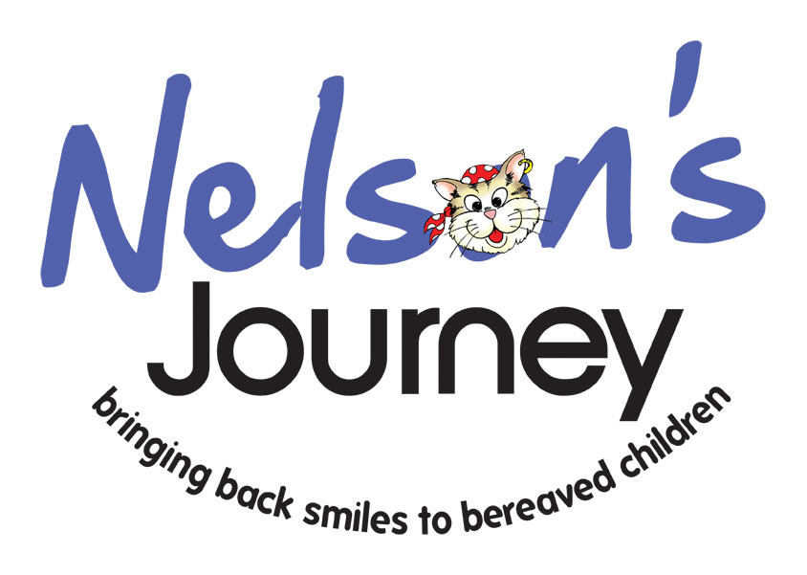

Welcome to Nelson’s Journey!

Volunteers are vital to the running of our charity and here’s how you can help!

Thank you for your interest in becoming a volunteer for Nelson’s Journey. Here is some information about Nelson’s Journey which we hope you will find helpful.

We welcome applications from volunteers with or without relevant professional experience in supporting bereaved children. There are plenty of different areas within the charity where you could help. These include helping directly with children and young people on our residential weekends & activity days, helping at fundraising & community events, delivering presentation talks to local groups in the community to raise awareness and helping in our office.

All applicants will be invited for an interview to discuss potential volunteering roles within Nelson’s Journey. Depending on the outcome of the interview and references, applicants who wish to attend our therapeutic weekends and activity days will be invited to attend two training days. These days give people the opportunity to learn about the work of Nelson’s Journey, the activities on the weekends and to share their own experiences of loss. Although personal experience of significant loss can be very helpful when supporting bereaved children, it is important that the volunteer is able to support children and young people with their grief and emotions, without it negatively impacting on their own wellbeing. To ensure the safety of children with whom we work, Nelson’s Journey also undertakes DBS checks.

Volunteering Opportunities

Residential Weekends
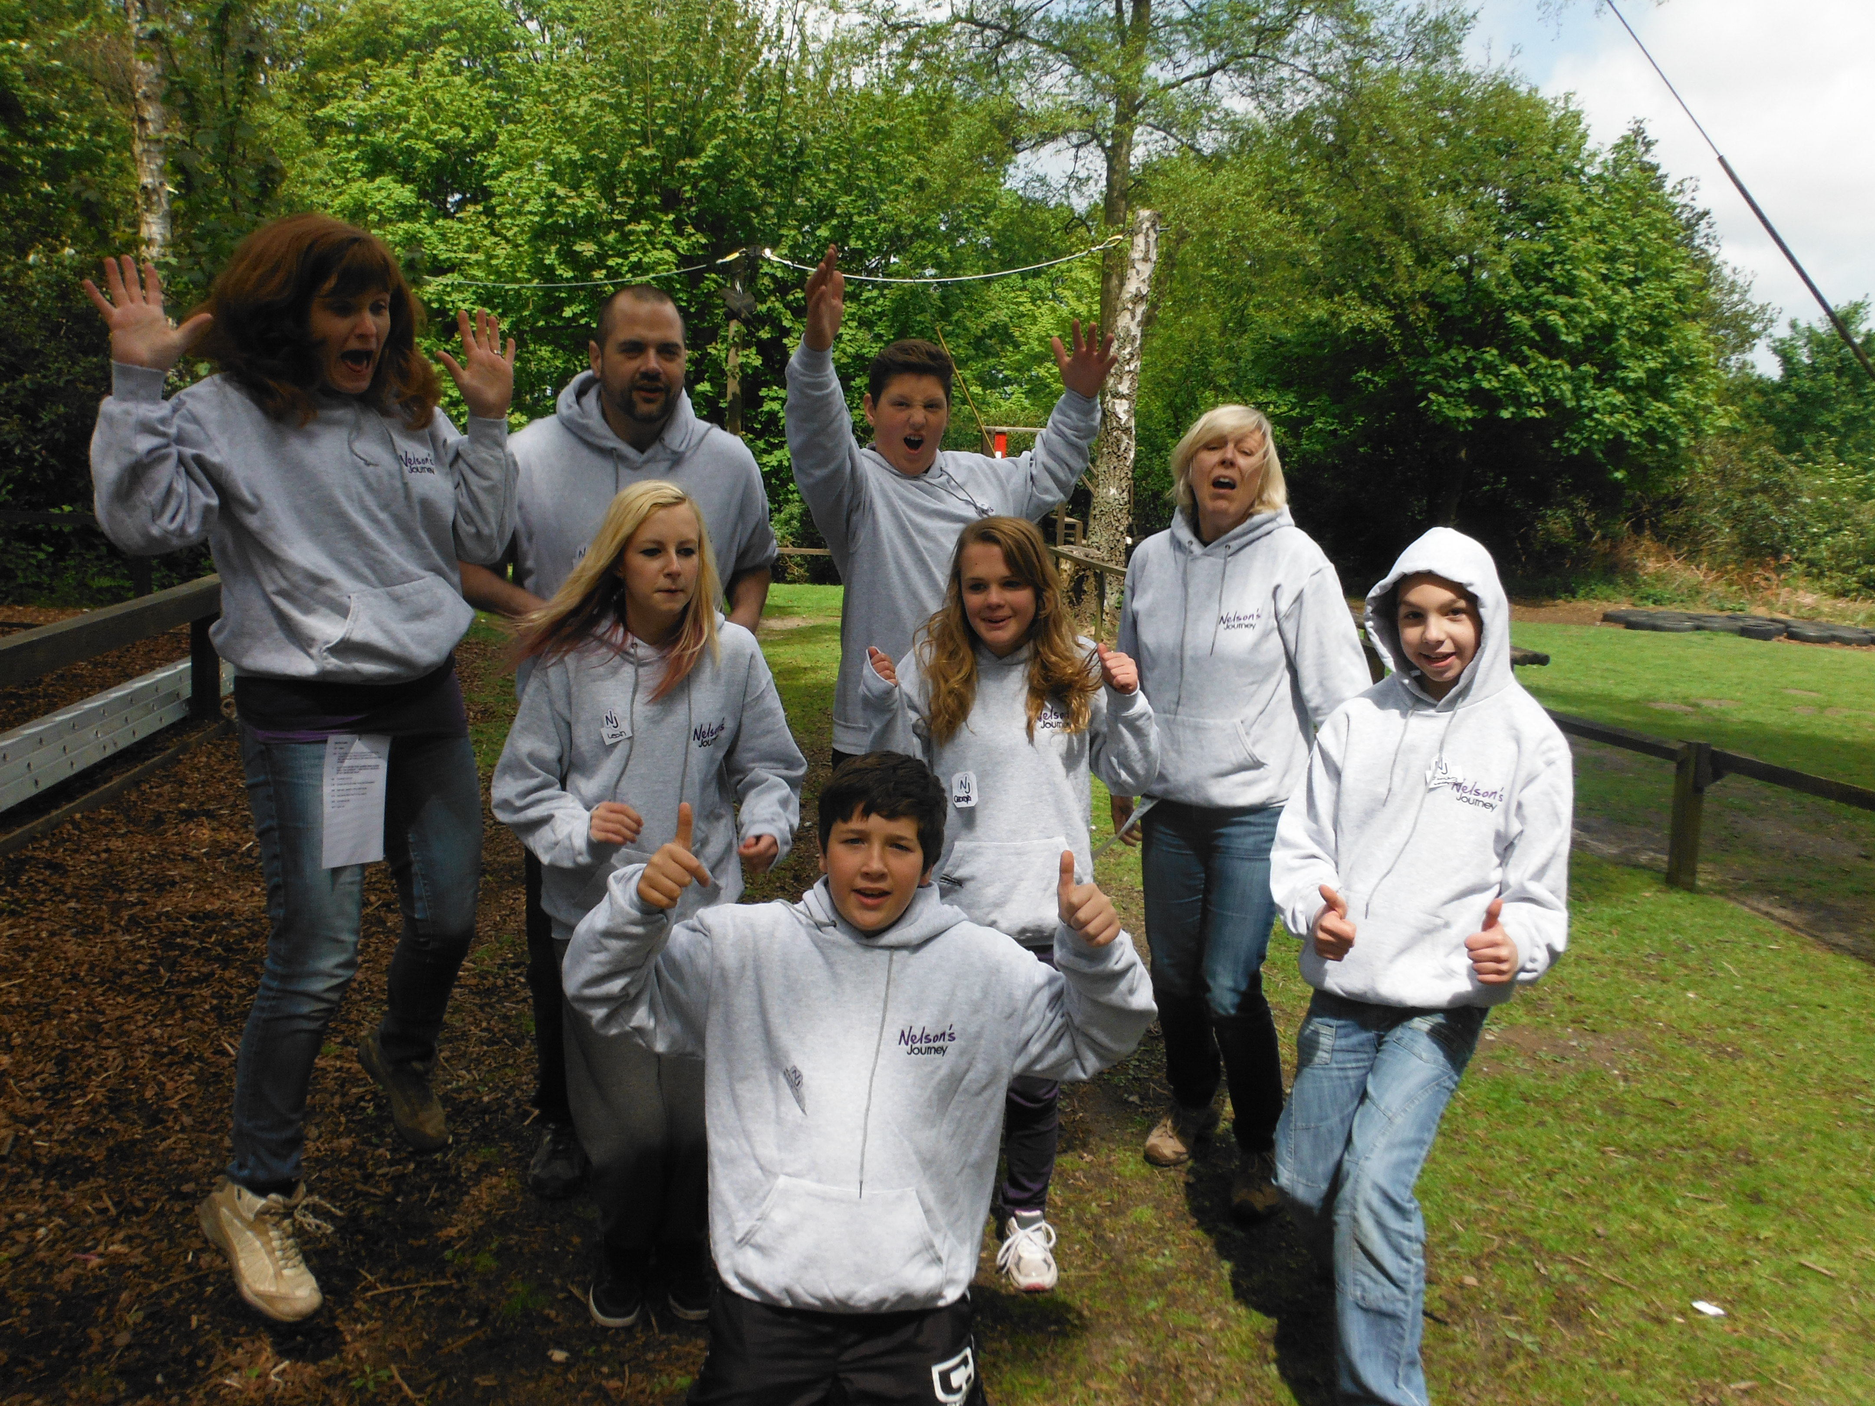
Children and young people are invited to an overnight stay
at Hilltop Outdoor Activity Centre where they can meet others who are bereaved of a significant person. We run separate weekends for children (8-12 years) and young people (aged 12 -17 years) The residential weekends consist of therapeutic activities including a candlelight ceremony and creating a memory jar; as well as team building activities. The weekend helps them to remember their special person and to share their experiences of bereavement. We use an average of twenty volunteers to help us on both the residential weekends and activity days.

Activity Days
Activity days are similar to the residential weekends but are a one day programme. Activity days allow us to support children of all ages. There are days for 0-8 year olds, 8-12 year olds and 12-17 year olds. There is a packed schedule of activities which assist the children and young people to preserve their memories and understand their feelings.

Fundraising Events
Events and fundraising are essential for our charity to keep going and volunteers ensure we are able to host and attend events. If this is something you would be interested in helping us with we will provide you with full training and all materials necessary to carry out your role and all travel expenses will be covered. You will have lots of opportunities to develop skills and try new things. Training for this role will last a day and will include how to talk to groups of people.

Office Administration
Volunteers assist our office staff to ensure that the preparation for our residentials and activity days run efficiently, by preparing resources and activities. Our admin volunteers also assist with preparing mailings, resources for fundraising and community events, as well as our professionals training sessions. Some tasks can be computer-based for those with good IT skills, but there are always other tasks that we would like help with. Whether you can volunteer a day per week or a more ad-hoc basis, please get in touch.

The difference you could make

Below is some feedback from parents/carers of children and young people who have received a service from us:

"They are not alone in losing someone they loved dearly"

"My children now have a better view of themselves. They no longer feel guilty for their father's death. There's more work to be done but there is massive improvement with confidence"

"Nelson's Journey let me see my daughter's smile again"

"She is more confident and no longer has worries or mental blocks. Her schoolwork has improved with increased self-esteem"

Whether it is working directly with the children on a residential weekend or activity day, doing talks to local groups or even collecting money in your local supermarket we would love to hear from you.

If you would like to get involved please complete a volunteer application form and return to enquiries@nelsonsjourney.org.uk.

Please do not hesitate to contact us either by telephone on 01603 431788 or at the email address above if you have any questions.

The Nelson’s Journey Team

