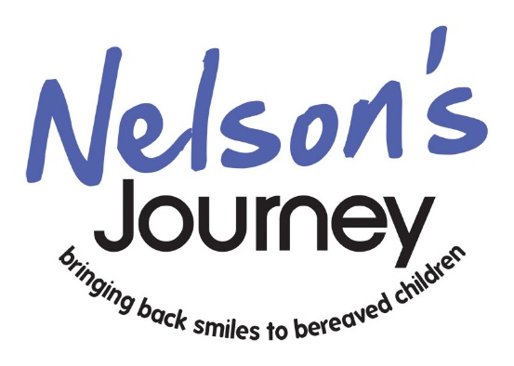
Referral form for Young People
Please note, you must be 16 or 17 years old to self-refer

YOUR DATA: Information provided by you on this form will be used by Nelson’s Journey to help us to understand your bereavement needs and to communicate with you about our services. We will not sell your data to other organisations for their marketing purposes. If we have a safeguarding or child protection concern about a child, then personal information may be shared with other agencies, such as the Police or Children’s Services. We have measures in place to protect your information, which will be held in paper and electronic forms. Your personal data will be processed throughout our contacts with you, and retained for a reasonable period afterwards after which your data will be securely destroyed. Our full Privacy Statement is available on our website or by calling us on 01603 431788.
Please fill in all the details below:
Young person’s Details
Full name:

Date of birth (you must be 16 or 17):

School/College:

Home address including postcode:

Home telephone number:

Mobile Phone Number:

Further details:
Name of deceased:

Relationship to the young person of deceased:

Date of death (exact date not required):

Cause of death:
The reason you would like support:
The reason you would like support:
Once complete, please either email to enquiries@nelsonsjourney.org.uk or post to:
Nelson's Journey
Bradbury Building - Smiles House
Octagon Business Park
Hospital Road
Little Plumstead
Norwich
NR13 5FH

Nelson’s Journey is a Charitable Incorporated Organisation; Registered Charity 1170605

